2. ReactJS-HOL

Home.js

import React from 'react';

function Home() {

return (

<div>

<h1>Welcome to the Home page of Student Management Portal</h1>

</div>

);

}

export default Home;

About.js

import React from 'react';

function About() {

return (

<div>

<h1>Welcome to the About page of the Student Management Portal</h1>

</div>

);

}

export default About;

Contact.js

import React from 'react';

function Contact() {

return (

<div>

<h1>Welcome to the Contact page of the Student Management Portal</h1>

</div>

);

}

export default Contact;

App.js

import React from 'react';

import Home from './Components/Home';

import About from './Components/About';

import Contact from './Components/Contact';

function App() {

return (

<div>

<Home />

<About />

<Contact />

</div>

);

}

export default App;

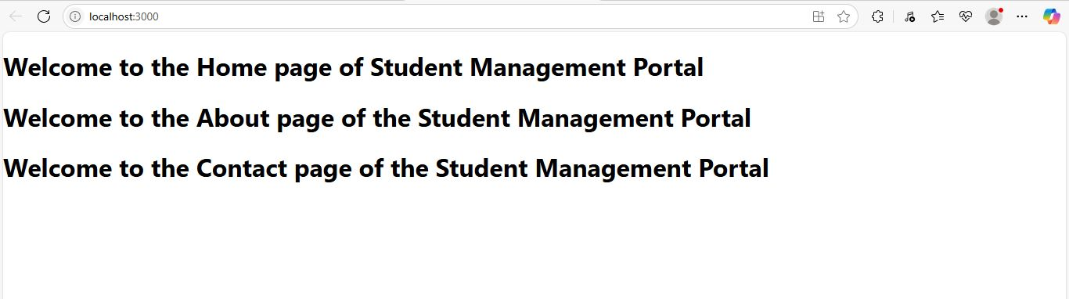

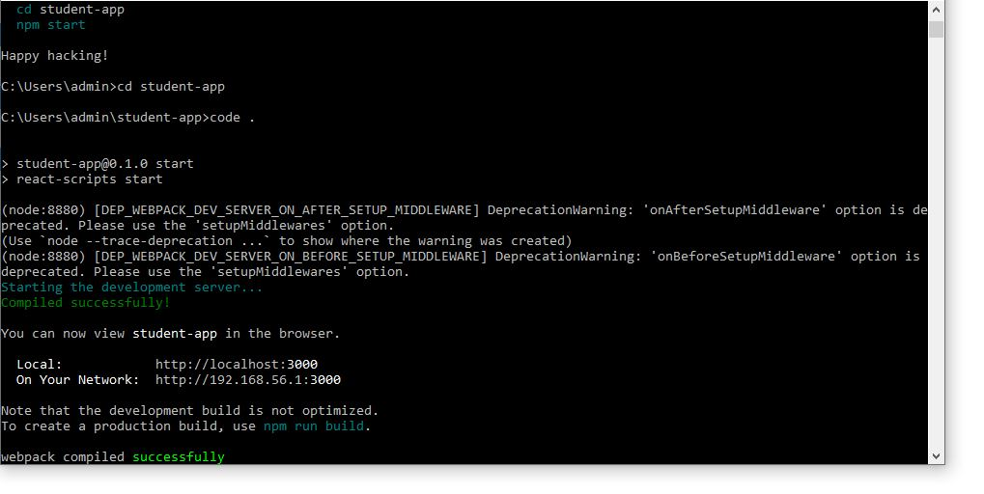

1. Explain React components
A React component is a reusable, independent piece of code that returns a React element to be rendered to the page. Components allow you to split the UI into smaller, isolated parts.

2. Identify the differences between components and JavaScript functions
Feature | React Components | JavaScript Functions
Purpose | Used to render UI | Used to execute a task or logic
Return Type | Returns JSX (React Elements) | Returns a value or result
React Lifecycle | Supports lifecycle methods (class) | No lifecycle
JSX Usage | Accepts and returns JSX | Doesn’t inherently support JSX
Props Support | Can receive props | Doesn't directly use props

3. Identify the types of components
There are two main types of components in React:
- Class Components
- Function Components

4. Explain class component
A class component is a React component defined using ES6 class syntax. It can hold state, use lifecycle methods, and returns JSX via the render() method.

import React, { Component } from 'react';

class Welcome extends Component {

render() {

return <h1>Welcome to React</h1>;

}

}

5. Explain function component
A function component is a JavaScript function that returns JSX. Since React 16.8, function components can use hooks like useState and useEffect for state and lifecycle logic.
function Welcome() {
return <h1>Welcome to React</h1>;
}

Define component constructor
In a class component, the constructor is used to initialize the state and bind methods. It is called once when the component is created.
constructor(props) {
super(props);
this.state = {
message: 'Hello'
};
}

7. Define render() function
The render() function is required in class components. It returns the JSX to be displayed on the UI.
render() {
return (
<div>
<h1>Welcome</h1>
</div>
);
}

